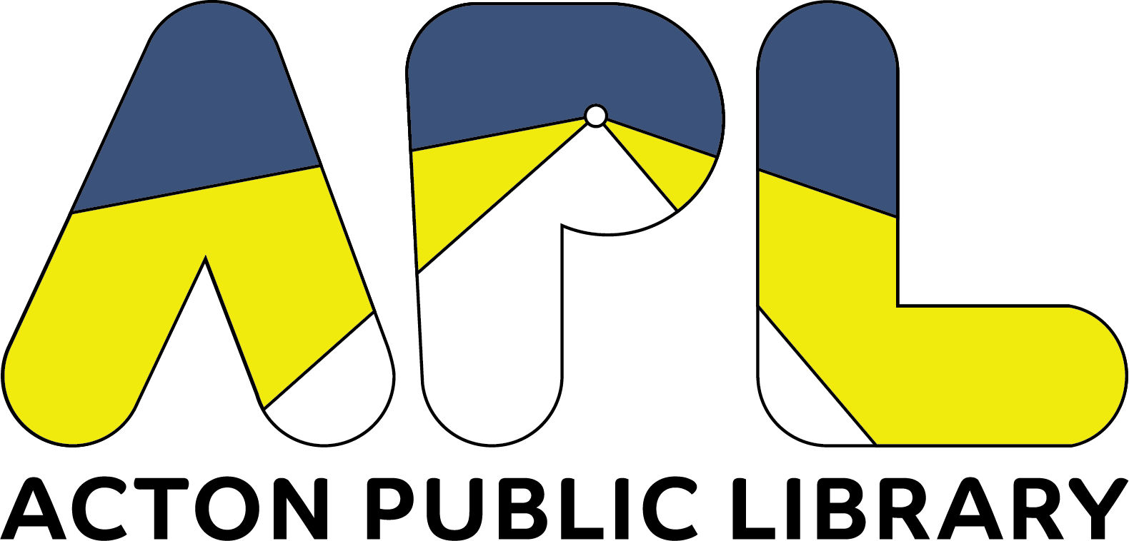
60 Old Boston Post Road Old Saybrook, CT 06475 (860)395-3184
Acton Public Library Board of Trustees Meeting

REGULAR MEETING AGENDA
Tuesday, June 13, 2023 – 6:30 P.M.
60 Old Boston Post Road
Main 2nd Floor Conference Room

Click here to access online meeting room
Dial-in option: +1 929 205 6099
Meeting ID: 827 5137 1999

- Call to Order/Pledge of Allegiance
- Approval of Minutes
- Public Comment
- Acceptance of Financial Report
- Acceptance of Non-Town Fund Report
- Acceptance of Statistics Report
- Correspondences
- Library Director’s Report
- Friend’s Report
- Old Business
- Memorial Day Parade Debrief
- Town emails: Nancy Walsh
- New Business
  - Celebrate Saybrook Street Party 6/25: possible participation
  - LJ Best Small-Town Library Nomination
- Adjournment

Contact actonlibrary@actonlibrary.org for meeting access password.

